SALESFORCE PAGE LAYOUT DOCUMENTATION
Courier Management System
This document defines the recommended Salesforce page layouts for the Courier Management System. It covers Customer, Shipment, Delivery Agent, Branch, Delivery Update, and Invoice objects, including field placement, related lists, assignment steps, testing, and screenshot evidence sections.

1. How to Configure a Page Layout
1. Open Salesforce Setup.
2. Open Object Manager.
3. Select the required custom object.
4. Select Page Layouts.
5. Open the existing layout or click New to create a new page layout.
6. Drag fields into suitable sections.
7. Create section headings where needed.
8. Configure field properties such as Read-Only or Required only when appropriate.
9. Add related lists to the Related Lists section.
10. Add buttons and actions if required.
11. Click Save.
12. Use Page Layout Assignment to assign the layout to the required profiles or record types.
13. Open a test record and verify the layout.

2. Recommended Page Layouts

2.1 Customer Page Layout
Object API Name: Customer__c
Suggested Layout Name: Customer Layout
Section | Fields / Components | Purpose
Customer Information | Customer Name, Email, Phone | Stores the main customer identification and contact details.
Address Information | Address, City, State, Postal Code | Stores the customer's delivery/contact address.
System Information | Created By, Created Date, Last Modified By, Last Modified Date | Displays Salesforce audit information.
Related Lists | Shipments | Shows shipments linked to the customer.

2.2 Shipment Page Layout
Object API Name: Shipment__c
Suggested Layout Name: Shipment Layout
Section | Fields / Components | Purpose
Shipment Information | Tracking Number, Customer, Shipment Date, Expected Delivery Date, Status | Displays core shipment information.
Branch & Agent Information | Origin Branch, Destination Branch, Assigned Delivery Agent | Shows operational assignments.
Package Information | Weight (kg), Shipping Charge | Stores parcel and charge information.
Delivery Information | Delivery Address | Stores final delivery destination.
System Information | Created By, Created Date, Last Modified By, Last Modified Date | Displays audit information.
Related Lists | Delivery Updates, Invoices | Shows shipment tracking history and billing information.

2.3 Delivery Agent Page Layout
Object API Name: Delivery_Agent__c
Suggested Layout Name: Delivery Agent Layout
Section | Fields / Components | Purpose
Agent Information | Delivery Agent Name, Phone, Email | Stores agent identity and contact information.
Work Information | Branch, Vehicle Number, Availability Status | Stores work assignment and availability.
System Information | Created By, Created Date, Last Modified By, Last Modified Date | Displays audit information.
Related Lists | Shipments | Shows shipments assigned to the delivery agent.

2.4 Branch Page Layout
Object API Name: Branch__c
Suggested Layout Name: Branch Layout
Section | Fields / Components | Purpose
Branch Information | Branch Name, Branch Code, Phone, Email | Stores branch identity and contact information.
Address Information | Address, City, State, Postal Code | Stores branch location details.
System Information | Created By, Created Date, Last Modified By, Last Modified Date | Displays audit information.
Related Lists | Delivery Agents, Origin Shipments, Destination Shipments | Shows records connected to the branch.

2.5 Delivery Update Page Layout
Object API Name: Delivery_Update__c
Suggested Layout Name: Delivery Update Layout
Section | Fields / Components | Purpose
Update Information | Update Number, Shipment, Status, Update Date/Time | Stores tracking update details.
Location & Remarks | Location, Remarks | Stores shipment location and additional notes.
System Information | Created By, Created Date, Last Modified By, Last Modified Date | Displays audit information.
Related Lists | Not required for the basic layout | This object mainly acts as a child record of Shipment.

2.6 Invoice Page Layout
Object API Name: Invoice__c
Suggested Layout Name: Invoice Layout
Section | Fields / Components | Purpose
Invoice Information | Invoice Number, Shipment, Invoice Date | Stores main invoice information.
Amount Information | Amount, Tax, Total Amount | Shows invoice calculations and totals.
Payment Information | Payment Status, Payment Method | Stores payment details.
System Information | Created By, Created Date, Last Modified By, Last Modified Date | Displays audit information.
Related Lists | Not required for the basic layout | Invoice is mainly linked to Shipment.

3. Recommended Related Lists
Object Page Layout | Related List | Reason
Customer | Shipments | Displays all shipments belonging to the customer.
Shipment | Delivery Updates | Displays shipment tracking history.
Shipment | Invoices | Displays invoice records related to the shipment.
Delivery Agent | Shipments | Displays shipments assigned to the agent.
Branch | Delivery Agents | Displays agents working under the branch.
Branch | Origin Shipments | Displays shipments originating from the branch.
Branch | Destination Shipments | Displays shipments assigned to the branch as destination.

4. Page Layout Assignment
1. Go to Setup → Object Manager.
2. Select the object.
3. Open Page Layouts.
4. Click Page Layout Assignment.
5. Click Edit Assignment.
6. Select the required profile or record type.
7. Choose the required page layout.
8. Click Save.
9. Log in or test with the target profile to verify that the correct layout is displayed.
Evidence / Screenshot
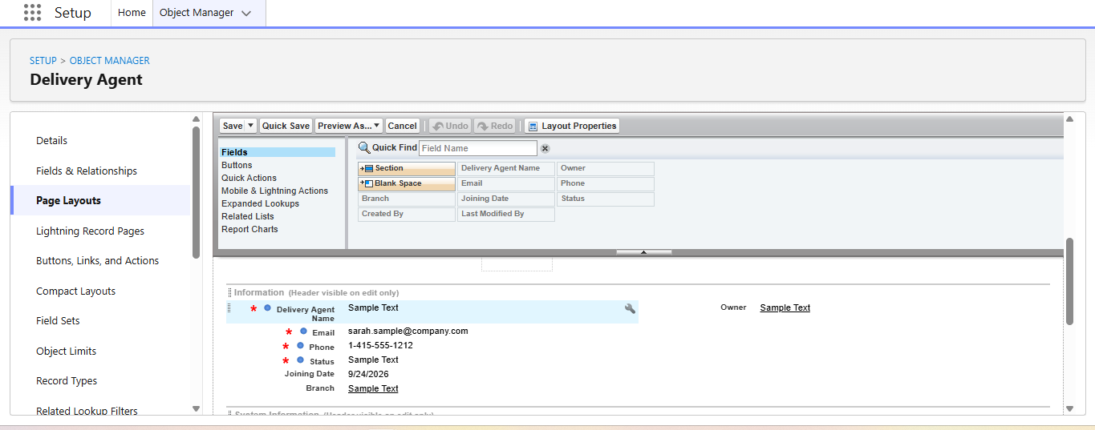

5. Recommended Field Arrangement
For a clean and easy-to-use layout, place the most frequently used fields near the top of the record. Keep address, financial, status, and system fields in separate sections. Use two-column sections where suitable.
- Place Name, Status, Customer, Tracking Number, or Invoice Number near the top.
- Keep contact fields together.
- Keep address fields in one section.
- Keep financial fields in a separate section.
- Keep system audit fields at the bottom.
- Place related lists after the main detail sections.
- Do not overcrowd the layout with fields that are not used.

6. Verification Checklist
☐ Customer page layout created and verified.
☐ Shipment page layout created and verified.
☐ Delivery Agent page layout created and verified.
☐ Branch page layout created and verified.
☐ Delivery Update page layout created and verified.
☐ Invoice page layout created and verified.
☐ Fields are arranged in logical sections.
☐ Related lists display correctly.
☐ Correct page layouts are assigned to the required profiles.
☐ Required and read-only field settings are correct.
☐ Screenshots have been added as evidence.

7. Important Note
If your Salesforce org uses additional fields or different API names, keep your working configuration and update this documentation accordingly. Only mark a page layout as completed after opening an actual record and verifying the field arrangement and related lists.

